

A Comparative Statistical Analysis of Five Major Cancers:
Patterns, Demographics, and Survival Outcomes Using SEER Data (2000–2023)

Submitted by: Sumit Kumar
Enrollment No:.474334
Examination Roll No:.24220STA061

Under Supervision of

Prof. Sanjay Kumar Singh
Department of Statistics
Banaras Hindu University, Varanasi
June 2026

Abstract
This report presents a comparative descriptive statistical analysis of five major cancer types — Breast, Liver, Lung and Bronchus, Prostate, and Stomach — using data from the Surveillance, Epidemiology, and End Results (SEER) Program of the U.S. National Cancer Institute. The dataset included 41,98,697 patients diagnosed between 2000 and 2023. Results showed substantial differences in cause specific survival outcomes: Prostate cancer and Breast cancer the highest (16 months), while Liver, Lung and Stomach cancer had the lowest (1, 2 and 2 months respectively). Lung cancer had the highest rate of Stage IV diagnosis (43.3%), while Prostate cancer had the highest rate of Stage I diagnosis (63.4%). Trends from 2000 to 2023 showed a steady rise in Breast cancer cases and a doubling of Liver cancer cases. The analysis used descriptive statistics, including measures of central tendency, dispersion, skewness, and kurtosis, along with bar charts, box plots, and trend lines.

Keywords: cancer statistics, SEER database, descriptive analysis, survival outcomes, comparative oncology

Acknowledgement
I would like to express my sincere gratitude to my supervisor, Prof. Sanjay Kumar Singh, Department of Statistics, Banaras Hindu University, for his invaluable guidance, patience, and constant encouragement throughout this project. His expertise in statistical analysis and genuine interest in this work made this project possible.
I am also grateful to the faculty members of the Department of Statistics, BHU, for building the statistical foundation through four semesters of rigorous teaching that I was able to apply directly in this project.
I would like to thank my friends Hrithivk and Shivani for their support and motivation throughout.
A special thanks to Tejaswi for her patience and constant encouragement during the long hours this project demanded.
Finally, I am deeply grateful to my family for their unconditional support, trust, and encouragement in everything I do.

Table of Contents
Abstract 1
Acknowledgement 2
1. A Comparative Statistical Analysis of Five Major Cancers: Patterns, Demographics, and Survival Outcomes Using SEER Data (2000–2023) 5
1.1 Objectives 5
2. Methods 6
2.1 Data Source 6
2.2 Sample 6
2.3 Variables 6
2.4 Data Cleaning 6
2.5 Statistical Analysis 7
3. Results 8
3.1 Sample Description 8
3.2 Age at Diagnosis 8
3.3 Sex Distribution 9
3.4 Cancer Stage at Diagnosis 10
3.5 Histological Type 11
3.6 Treatment Patterns 11
3.7 Survival Time (Cause-specific) 12
3.8 Geographical distribution 13
3.9 Household Income 14
3.10 Trends From 2000-2023 15
4. Discussion 16
5. Limitations 18
6. Conclusion 19
7. References 20

A Comparative Statistical Analysis of Five Major Cancers: Patterns, Demographics, and Survival Outcomes Using SEER Data (2000–2023)
Cancer remains one of the leading causes of death worldwide. The World Health Organization (2024) reports that cancer causes nearly 10 million deaths each year, making it the second leading cause of death globally after cardiovascular disease. Early diagnosis and an understanding of demographic and socioeconomic risk factors are critical to improving outcomes.

This study compares five major cancer types: Breast, Liver, Lung and Bronchus, Prostate, and Stomach using data from the Surveillance, Epidemiology, and End Results (SEER) Program (National Cancer Institute, 2026). SEER is maintained by the U.S. National Cancer Institute and covers approximately 34.6% of the U.S. population across 17 cancer registries, making it one of the most widely used cancer datasets in research.

Different cancers vary widely in how they present, how they are treated, and how patients survive. Comparing several cancer types side by side using the same variables and methods can highlight which cancers are detected early, which are detected late, and how survival differs across groups.

1.1 Objectives
The objectives of this study were to:
- describe and compare demographic characteristics (age, sex, marital status) across the five cancer types;
- compare the stage at diagnosis across cancer types;
- describe the dominant histological (cell) type for each cancer;
- compare treatment patterns (surgery, radiation, chemotherapy) across cancer types;
- compare survival time across cancer types; and
- examine trends in case counts from 2000 to 2023.

Methods

2.1 Data Source
Data were obtained from the SEER Research Database, 17 Registries, November 2025 Submission (2000–2023), released by the National Cancer Institute in April 2026. Access was granted through a signed Data Use Agreement, and data were extracted using SEER*Stat software.

2.2 Sample
Five major Cancer types were selected: Breast Cancer, Liver Cancer, Lung and Bronchus Cancer, Prostate Cancer and Stomach Cancer. All malignant cases diagnosed from 2000 – 2023 were included. Records with missing survival time were removed. Table 1 shows final sample size from each cancer.

Cancer Type | n | %
Breast | 1435703 | 34.19
Prostate | 1324278 | 31.54
Lung and Bronchus | 1133140 | 26.99
Stomach | 154503 | 3.68
Liver | 151073 | 3.60
Total | 4198697 | 100
Table 1 Final counts by Cancer Type

2.3 Variables
Sixteen variables were used, covering five areas: demographics (age, sex, race, marital status, year of diagnosis), tumor characteristics (primary site, histologic type), stage (Combined Summary Stage), treatment (radiation, chemotherapy, surgery), outcome (survival months, vital status, cause of death), and socioeconomic factors (median household income, rural-urban code).

2.4 Data Cleaning
Data cleaning was carried in Python using Pandas and NumPy libraries. Same steps were applied to all five cancer datasets.
Age and income, which were originally recorded as ranges (e.g., ‘70-74 years’, $100,000 - $109,999), were converted to numeric midpoints. Primary Site ICD-O-3 codes (e.g., 341,343…), were replaced with names of Anatomical sites which these codes represented. Histologic Type codes were grouped into cancer-specific categories. Combined summary stage, were simplified into stage I, II, …, Unknown. Radiation, Chemotherapy and Surgery were combined into one Treatment variable with all possible treatment combinations. Vital status was converted from alive or dead to 0 or 1.

2.5 Statistical Analysis
Descriptive statistics were used throughout, include frequencies and percentages for categorical variable mean, median, standard deviation, quartiles, skewness and kurtosis for continuous variable (age and survival time). Results are shown using bar charts, line charts, stacked bar charts and boxplots.

Results

3.1 Sample Description
The final sample included 41,98,697 patients. Breast cancer was largest group (14,35,703; 34.19%), followed by Prostate (13,24,278; 31.54%), Lung and Bronchus (11,33,140; 26.99%), Stomach (1,54,503; 3.68%) and Liver (1,51,073; 3.60%). Figure 1 shows the number of patients in each group.
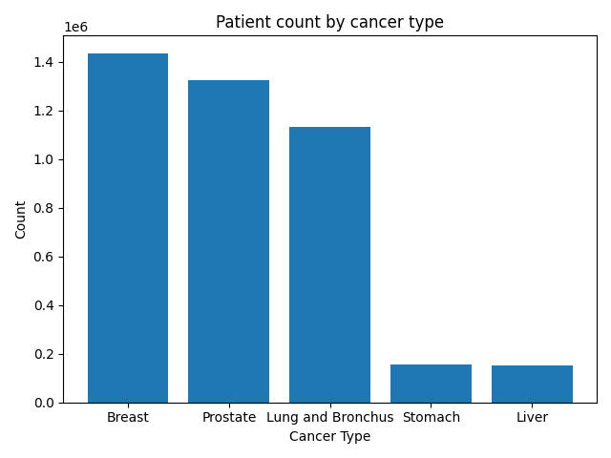
Fig. 1

3.2 Age at Diagnosis
Table 2 show statistics for each cancer type. Lung and Bronchus cancer patients were oldest on average age (Mean = 69.8 and Median = 72), and Breast cancer patients were youngest on average age (Mean = 62 and Median = 62). Liver cancer had most peaked distribution (Kurtosis = 3.73). Figure 2 shows age distribution across cancer types.
Cancer Type | n | Mean | SD | Min | Median | Max | Skew | Kurtosis
Breast | 1435703 | 62.0 | 13.8 | 0 | 62 | 90 | -0.06 | -0.61
Liver | 151073 | 64.9 | 12.9 | 0 | 67 | 90 | -1.01 | 3.73
Lung and Bronchus | 1133140 | 69.8 | 11.0 | 0 | 72 | 90 | -0.45 | 0.25
Prostate | 1324278 | 67.3 | 9.4 | 0 | 67 | 90 | 0.05 | -0.18
Stomach | 154503 | 67.5 | 14.0 | 0 | 67 | 90 | -0.54 | -0.07
Table 2 Age at diagnosis by Cancer Type
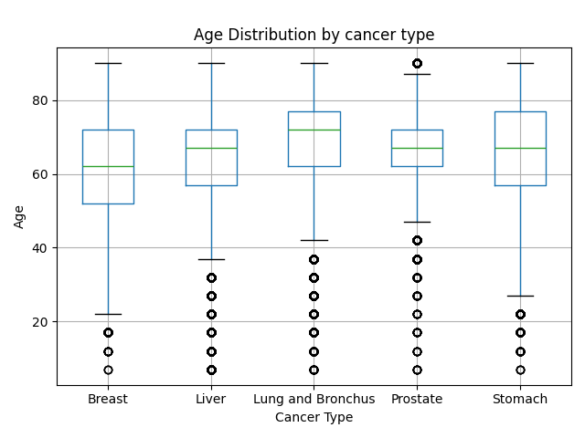
Fig. 2

3.3 Sex Distribution
As expected, Breast cancer was almost entirely diagnosed in females (99.24%), and Prostate cancer only in males (100%). Liver cancer showed was diagnosed majorly in males (73.84%). Lung and Bronchus cancer was balanced in males (52.39%) and females (47.61%). Stomach cancer showed a moderate male majority (~60%). Figure 3 shows sex distribution across cancer types.
Cancer Type | Sex | Frequency | Percentage
Breast | Female | 1424810 | 99.24
Breast | Male | 10893 | 0.76
Liver | Male | 111546 | 73.84
Liver | Female | 39527 | 26.16
Lung and Bronchus | Male | 593634 | 52.39
Lung and Bronchus | Female | 539506 | 47.61
Prostate | Male | 1324278 | 100.00
Stomach | Male | 92626 | 59.95
Stomach | Female | 61877 | 40.05
Table 3 Sex distribution by Cancer Type
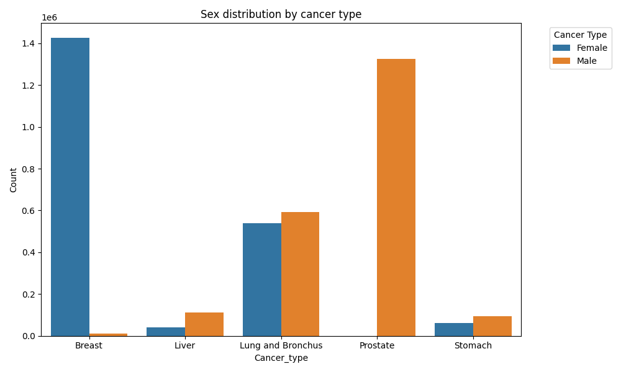
Fig. 3

3.4 Cancer Stage at Diagnosis
Table 4 shows stage distribution. Prostate cancer had highest rate of diagnosis at stage I (63.4%), consistent with widespread PSA screening. Lung and Bronchus cancer had highest rate of diagnosis at stage IV (43.33%), worst pattern among others. Figure 4 shows stage distribution across cancer types.

Cancer | I | II | III | IV | Unknown
Breast | 54.98 | 1.68 | 22.37 | 5.01 | 15.95
Liver | 43.14 | 19.75 | 3.25 | 14.01 | 19.86
Lung and Bronchus | 18.63 | 5.73 | 12.33 | 43.33 | 19.98
Prostate | 63.4 | 8.74 | 1.82 | 5.79 | 20.25
Stomach | 26.61 | 4 | 16.85 | 28.92 | 23.63
Table 4 Stage distribution by Cancer Type (%)
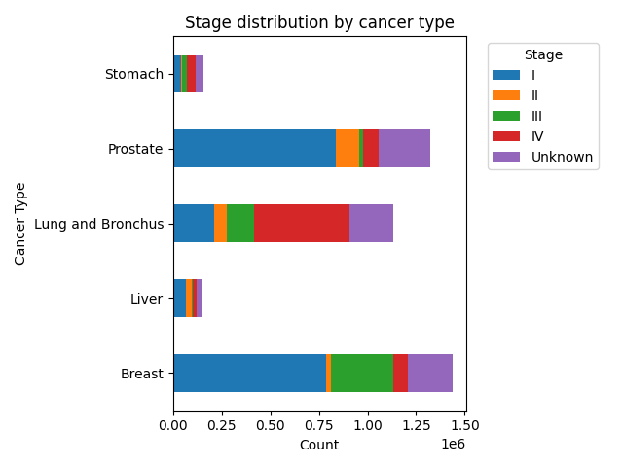
Fig. 4

3.5 Histological Type
Table 5 shows the most common histological subtypes for each cancer. Breast and Prostate cancer were dominated by a single subtype (Ductal/Lobular Carcinoma,95.05% and Adenocarcinoma, 96.6%, respectively). Lung and Bronchus cancer was more varied, with most common subtype (Large Cell Carcinoma, 33.04%).

Cancer Type | Histologic Type ICD-O-3 | Frequency | Percentage
Lung and Bronchus | Large Cell Carcinoma | 374363 | 33.037665
Stomach | Adenocarcinoma | 105202 | 68.090587
Liver | Hepatocellular Carcinoma | 135843 | 89.918781
Breast | Ductal/Lobular Carcinoma | 1364630 | 95.049603
Prostate | Adenocarcinoma | 1279938 | 96.651760
Table 5 Histological type distribution by Cancer Type (%)

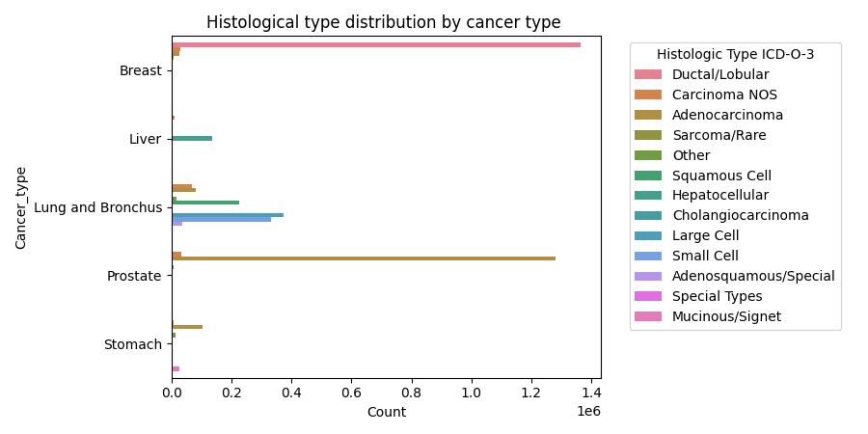
Fig. 5

3.6 Treatment Patterns
Breast cancer often involved surgery plus radiation (3,37,697; 30.27%). Liver cancer most often involved chemotherapy (40,885; 62.19%). Prostate cancer heavily relied on radiation alone (4,21,032; 81.61%), and Lung and Bronchus cancer was more varied with most involved radiation plus chemotherapy (28.59%), followed by surgery (21.24%), chemotherapy (20.72%) and radiation (20.57%). Figure 6 shows treatment pattern distribution by cancer type.

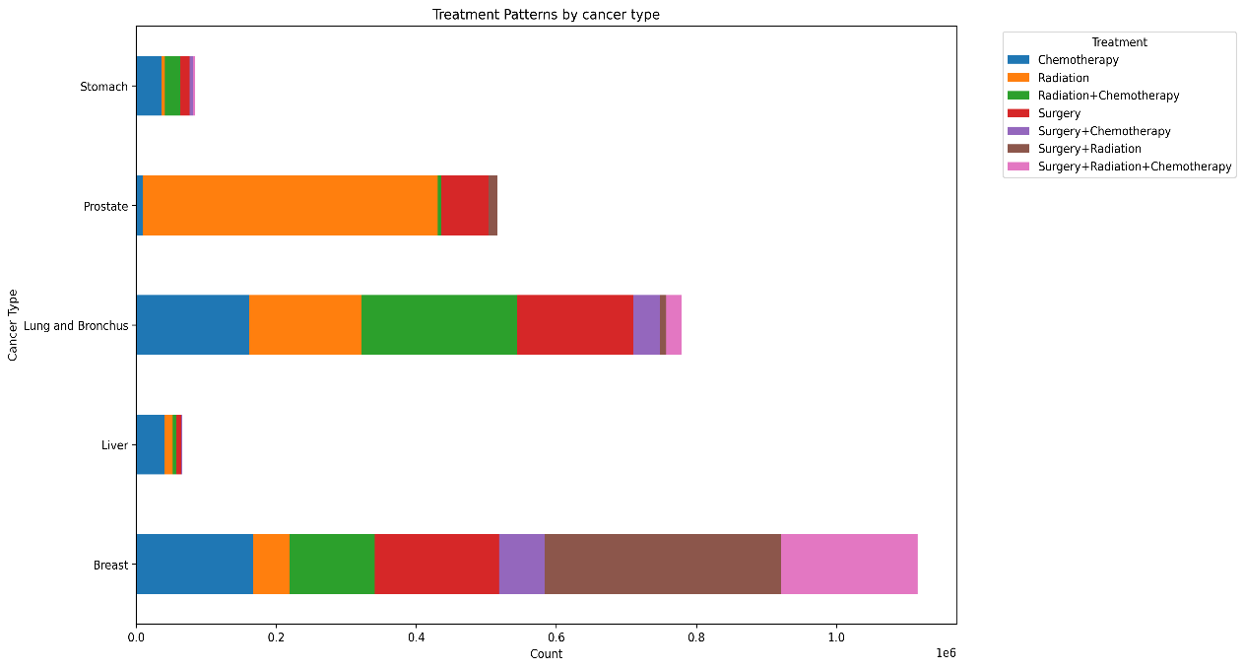
Fig. 6

3.7 Survival Time (Cause-specific)
Table 6 shows survival time (in months) for each cancer type. Prostate and Breast cancer had highest median survival (16 months). Liver cancer had the shortest median survival (1 months). And Lung and Stomach cancer had second lowest survival (2 months). Liver, Lung and stomach cancer showed positive skew (3.23, 3.71, 4.36 respectively) and high kurtosis (15.15, 19.03, 28.52 respectively), meaning that most patients had short survival time but few survived much longer and survival time had a peaked distribution. Figure 7 shows survival time distribution by cancer type.
Note: n values here are smaller because only patients who died from their primary cancer are included.
Cancer Type | n | Mean | SD | Min | Median | Max | skewness | kurtosis
Breast | 1,95,109 | 52.51 | 49.80 | 0 | 16 | 287 | 1.47 | 2.08
Liver | 77,880 | 12.98 | 20.38 | 0 | 1 | 252 | 3.23 | 15.15
Lung and Bronchus | 7,19,108 | 14.46 | 23.55 | 0 | 2 | 284 | 3.71 | 19.03
Prostate | 113918 | 61.10 | 57.71 | 0 | 16 | 287 | 1.18 | 0.75
Stomach | 65326 | 12.44 | 19.88 | 0 | 2 | 280 | 4.36 | 28.52
Table 6 Survival time (months) distribution by Cancer Type
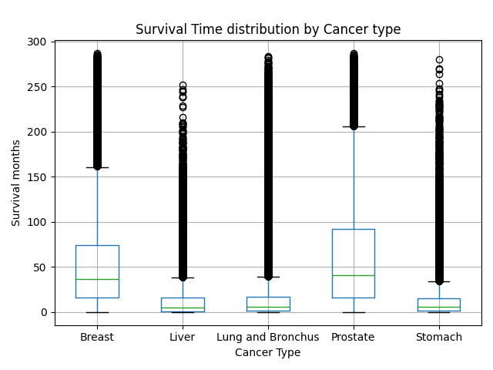
Fig. 7

3.8 Geographical distribution
Across all five cancers, most patients lived in large metropolitan areas (over 1 million people), ranging from 54.3% for Lung cancer to 63.3% for Stomach cancer. Lung cancer had the highest share of patients from non-metropolitan areas (16.0%). Figure 8 shows the geographic breakdown.
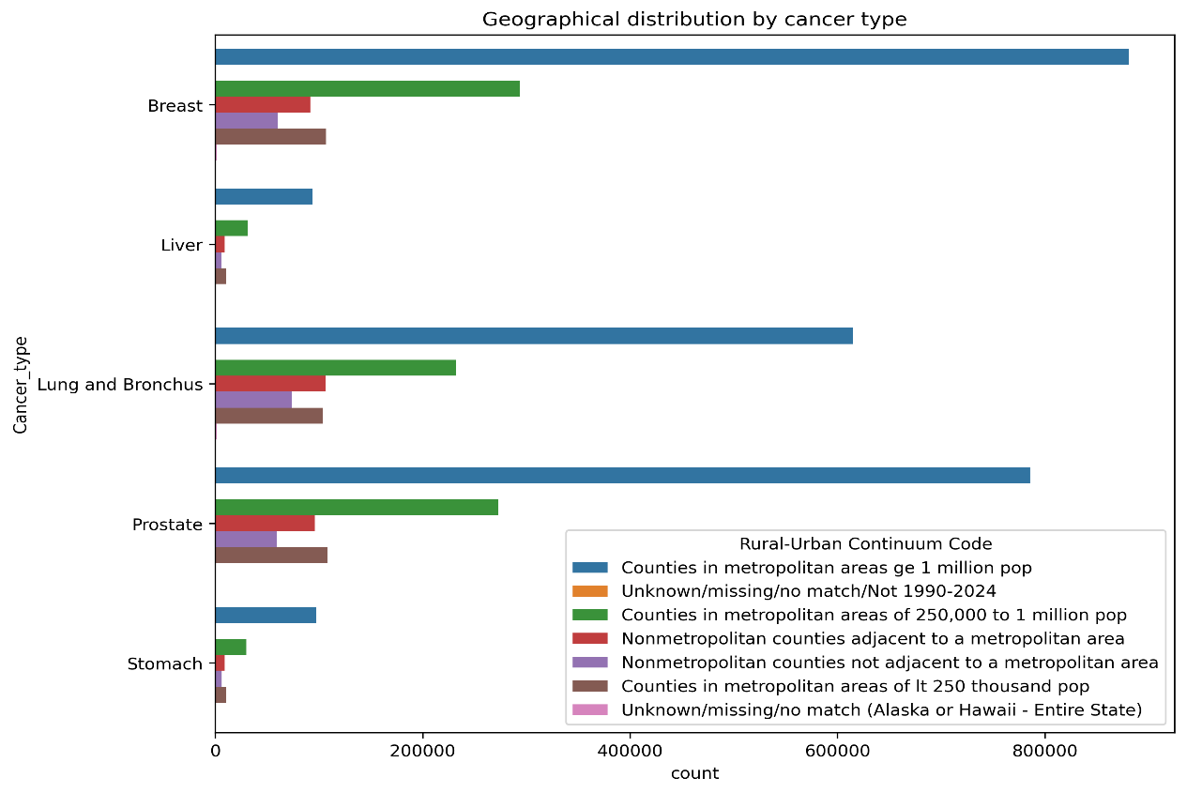
Fig. 8

3.9 Household Income
Mean household income (in USD) was similar across all five cancers, ranging from $82,858.03(Lung) to $86,434.89(Stomach), as shown in Table 7 and Figures 9(a) and 9(b).
Cancer Type | Mean Income (USD)
Breast | 86973.13
Liver | 85525.37
Lung and Bronchus | 82858.03
Prostate | 86138.82
Stomach | 86434.89
Table 7 Mean household income (USD) by Cancer Type
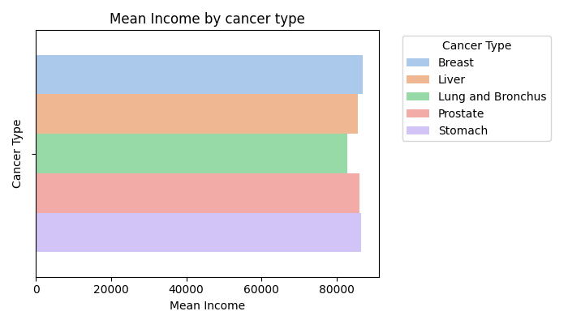
Fig. 9(a)
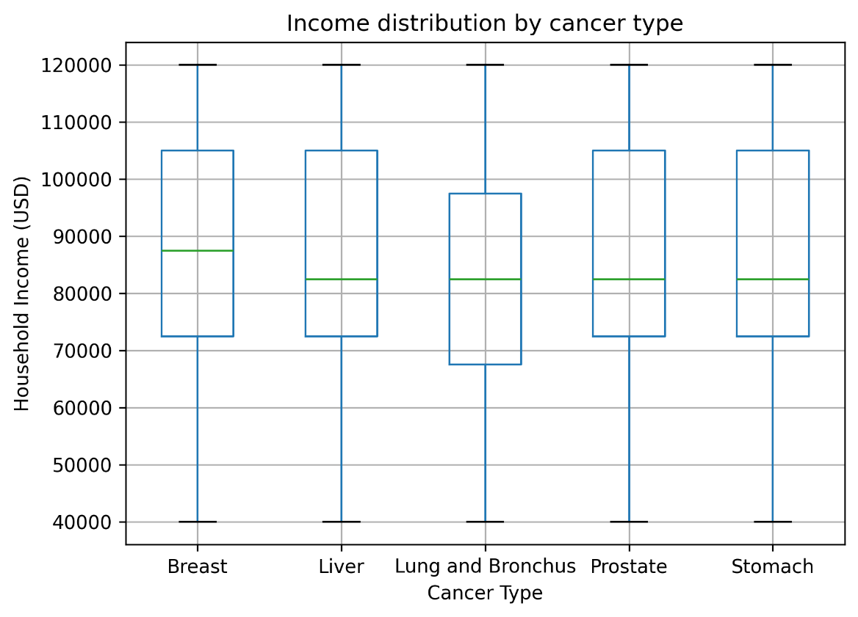
Fig. 9(b)

3.10 Trends From 2000-2023
Figure 10 shows yearly case counts. Breast cancer cases rose steadily, from about 50,799 in 2000 to 74,200 in 2023 (+46.1%). Prostate cancer dipped sharply around 2012–2015 — consistent with the 2012 change in PSA screening guidelines — before recovering. Lung cancer stayed roughly stable. Liver cancer more than doubled, from 3,303 cases in 2000 to 7,527 in 2023. Stomach cancer rose gradually from 5,649 to 8,410 cases.

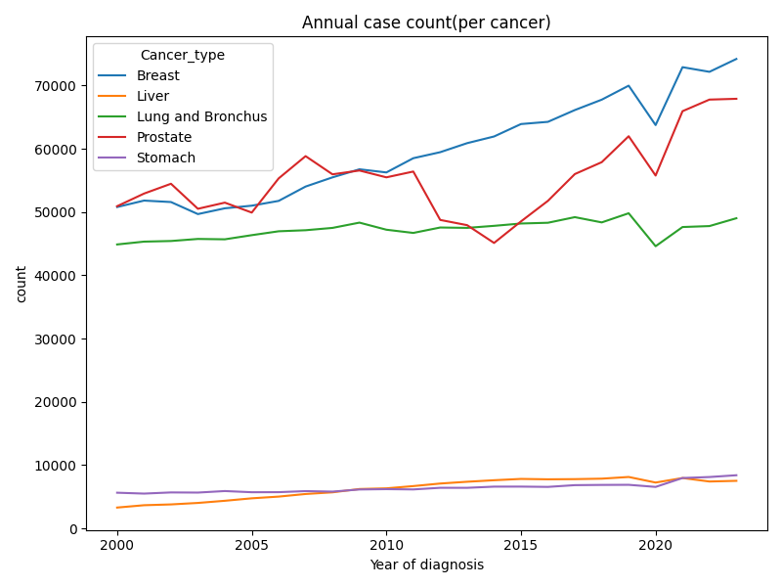
Fig. 10

Discussion
This study compared five major cancer types using over four million patient records from the SEER database. The clearest result was the large gap in survival between cancers: Prostate and Breast cancer patients survive far longer (median 16 months) than Liver and Lung cancer patients (median 1 and 2 months). This gap appears closely linked to stage at diagnosis. Prostate cancer is often caught early because of PSA screening (63.4% Stage I), while Lung cancer is most often caught late (43.3% Stage IV), when treatment options are limited.

Skewness and kurtosis added useful details over median. Liver and Lung cancer survival time were skewed, meaning most of their patients survived short but a small group survived longer, likely those diagnosed earlier or responded well to treatments. Breast and Prostate survival times were symmetric suggesting more consistent outcomes across patients.

Sex differences matched with was earlier known: Breast cancer was overwhelmingly diagnosed in females, Prostate cancer only in males and Liver cancer more often in males which is directly linked to their alcohol use. Lung cancer was nearly balanced between sexes, reflecting how occupational exposures and smoking rates have converged between males and females over time

Histology results matched known cancer biology: Breast cancer is mostly Ductal/Lobular, Liver cancer mostly Hepatocellular, and Prostate and Stomach cancers mostly Adenocarcinoma. Lung cancer was the most varied, which fits its known biological complexity and explains why lung cancer treatment differs more from patient to patient.

Treatment followed expected clinical practice: Radiation alone was common in Prostate cancer, surgery plus radiation was common in Breast cancer and chemotherapy was alone common in Liver cancer where surgery is often not possible. Lung cancer patients had most varied treatment patterns, which is likely due to variety in histology of patients.

Most patients across all cancers lived in large cities, which is likely due to high population density in large cities and also because cities offer easier access to screening and treatment.
Average household income across all cancers was similar, though Lung cancer patients had lower average income, which fits known link between lower income and higher Lung cancer risk.

Trends over 23 years showed that: Liver cancer cases are doubled and Lung cancer has been stable through the years. A clear dip in Prostate cancer cases during 2012-2015 lines up closely with change in screening guidelines, showing how public health policy can affect how cancer cases are recorded.

Limitations
This study has several limitations:
- SEER data comes from United States, so results may not be directly applied to other countries, including India, where screening practices, lifestyle factor and healthcare access differs.
- SEER records are only the first course of treatment later treatments and recurrences are not recorded.
- Age and income were stored as ranges and converted to their midpoints, which is only approximation of true value.
- Between 15% and 24% of patients had unknown stage at diagnosis, which may affect stage related findings.
- SEER does not include smoking history, alcohol habit, family history and genetic information, all of which are important risk factors.
- Income was only measure at county level rather than each individual patient, making it rough estimate of socioeconomic status.
Finally, this study is descriptive only; it does not include statistical hypothesis testing or survival modeling such as Kaplan-Meier curve or Cox-regression, which could identify factors that independently predict survival.

Conclusion

This study compared five major cancer types using more than four million patient records from the SEER database spanning 2000 to 2023. The clearest result was the large difference in survival: Prostate and Breast cancer patients lived far longer than Liver and Lung cancer patients, largely because Prostate and Breast cancers are more often caught at an early stage. Lung cancer stood out as the cancer with the most late-stage diagnoses and the most varied cell types, while Breast, Prostate, and Stomach cancers were each dominated by one main cell type.

Trends over 23 years showed rising Breast and Liver cancer cases, a stable Lung cancer burden, and a clear dip in Prostate cancer cases linked to a real change in screening guidelines around 2012. Most patients across all five cancers lived in large cities, and household income did not differ much between cancer types.

Overall, this study shows how useful a large, well-documented dataset like SEER can be for comparing cancers side by side. Future research could add survival modeling, such as Kaplan-Meier curves, to study survival in more depth, and could include risk factors such as smoking or genetic markers if such data become available.

7. References
1. Surveillance, Epidemiology, and End Results (SEER) Program (www.seer.cancer.gov) SEER*Stat Database: Incidence - SEER Research Data, 17 Registries, Nov 2025 Sub (2000–2023), National Cancer Institute, DCCPS, Surveillance Research Program, released April 2026.
2. Sung, H., Ferlay, J., Siegel, R. L., Laversanne, M., Soerjomataram, I., Jemal, A., & Bray, F. (2021). Global cancer statistics 2020: GLOBOCAN estimates of incidence and mortality worldwide for 36 cancers in 185 countries. CA: A Cancer Journal for Clinicians, 71(3), 209–249.
3. Siegel, R. L., Miller, K. D., Wagle, N. S., & Jemal, A. (2023). Cancer statistics, 2023. CA: A Cancer Journal for Clinicians, 73(1), 17–48.
4. Goon, A. M., Gupta, M. K., & Das Gupta, B. (2014). Fundamentals of Statistics, Vol. I (5th ed.). World Press, Calcutta.
5. Holcomb, Z. C. (2016). Fundamentals of Descriptive Statistics. Routledge.
6. U.S. Preventive Services Task Force. (2012). Screening for prostate cancer: U.S. Preventive Services Task Force recommendation statement. Annals of Internal Medicine, 157(2), 120–134.
7. Wang, S., Liu, Q., Zhang, Y., & Liu, L. (2021). Prognosis and survival analysis of 922,317 lung cancer patients. Frontiers in Oncology, 11, 766671.
8. McKinney, W. (2010). Data structures for statistical computing in Python. Proceedings of the 9th Python in Science Conference, 445, 51–56.
9. Hunter, J. D. (2007). Matplotlib: A 2D graphics environment. Computing in Science & Engineering, 9(3), 90–95.
10. World Health Organization. (2024). Cancer. https://www.who.int/news-room/fact-sheets/detail/cancer

